Tundra

The tundra is the second-largest vegetation region in the country. Located in Canada’s Arctic, the tundra is treeless because of low summer temperatures (a mean less than 11OC) and short growing season (1.5-3.5 months). Small shrubs, mosses and lichens grow in this short period. Most of the tundra is permanently frozen ground called Permafrost. During the summer, only the top 20-60 cm layer of soul above the permafrost – the Active Layer – thaws. The soil has low levels of nutrient such as phosphorus and nitrogen. As well, poor drainage in low lying areas means the soil is water-logged. With the short growing season, most tundra plants bloom and mature to produce seeds very quickly. In the High Arctic, vegetation is sparser. In this high latitude, summers are colder and total annual precipitation is less (between 100 and 200 mm). This land is a polar semi-desert. The vegetation is clumps of dwarf shrubs, lichens and mosses, scattered clumps of grass and ruches and small flowering plants such as poppy and chickweed.

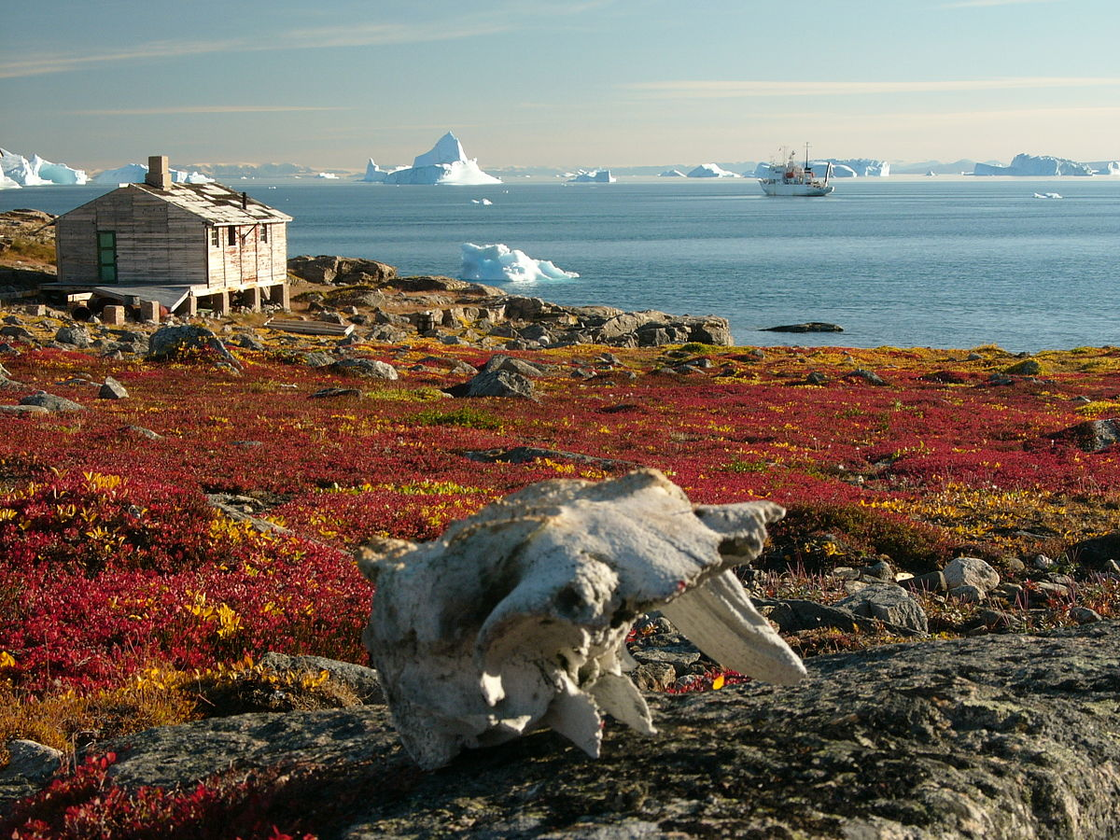
Boreal and Taiga Forest

Traveling directly south from the Arctic Tundra, the Boreal and Taiga Forest is encountered. This region is Canada’s largest vegetation region. The region is dominated by a sparely populated community of plants that are capable of surviving cool, short summers and long, cold winters. Due to the immense size of the region, variations in vegetation occur. In the north, the most common vegetation is Coniferous Trees or Evergreens. Coniferous trees are trees with needle-like leaves that, over the course of one year, do NOT lose all their needles. Since the coniferous trees keep most of their needles, the soil layer below the evergreen is very shallow (i.e., little decaying vegetation). The soil is grey in colour. Moreover, the needles of the tree are very acidic…. A competitive advantage over other trees. The surrounding soil is also acidic keeping competition for resources low. The entire region is poorly drained, and much of the Region is wetlands such as bogs and fens.

Bigger trees are more common in the southern part of the Region. Coniferous tree species include white spruce, black spruce and balsam fir. Some deciduous trees (e.g., white birch and popular) grow in the southern parts of the Boreal Forest. Typical wetland plant species include black spruce, larch, eastern red cedar, willows, Labrador tea, bog rosemary, cloudberry, sedges, sphagnum and mosses.

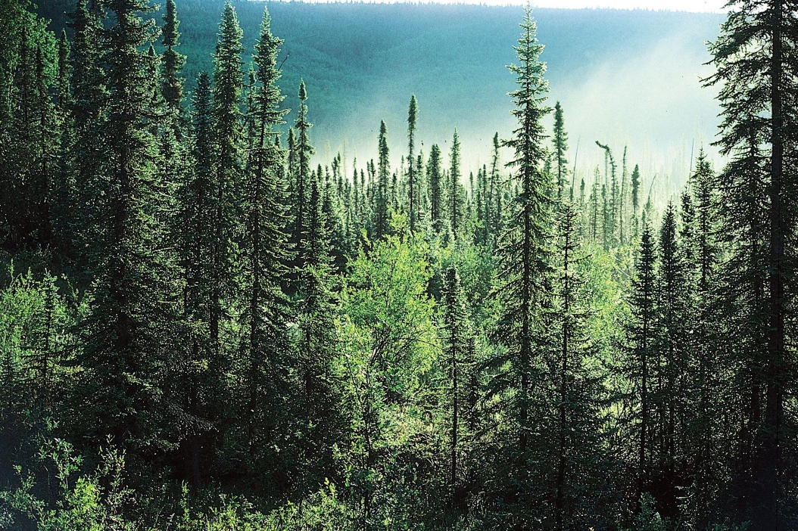
Mixed Forest

Mixed Forest is a region on coniferous and deciduous trees. Pine and spruce trees are found in the same forest as maple and oak trees. The region is a TRANSITION ZONE between the northern Boreal Forest and the southern deciduous forests. Mixed Forest is found in southeastern Canada (i.e., Maritimes, southern Quebec and southern Ontario). The region has abundant and regular precipitation. The humus from the leaves creates rich and fertile topsoil. The region is very suitable farming.

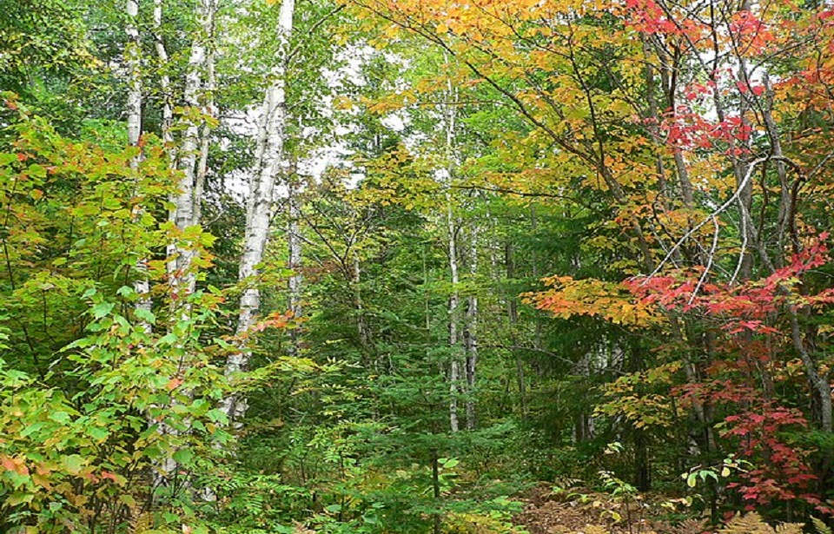

Deciduous Forest

The only true deciduous forest in Canada is a small region is southwestern Ontario. This area is the northern limit to many deciduous tree species. The area has been cleared extensively for farming. Only remnant pockets of the original forests remain. Summers are hot, winters mild and precipitation occurs throughout the year. The conditions are ideas for hardwoods such as maple, beech, ash and hickory. The soil content is similar to the Mixed Forest region due to the hardwood trees. The soil is fertile and ideal for farming.

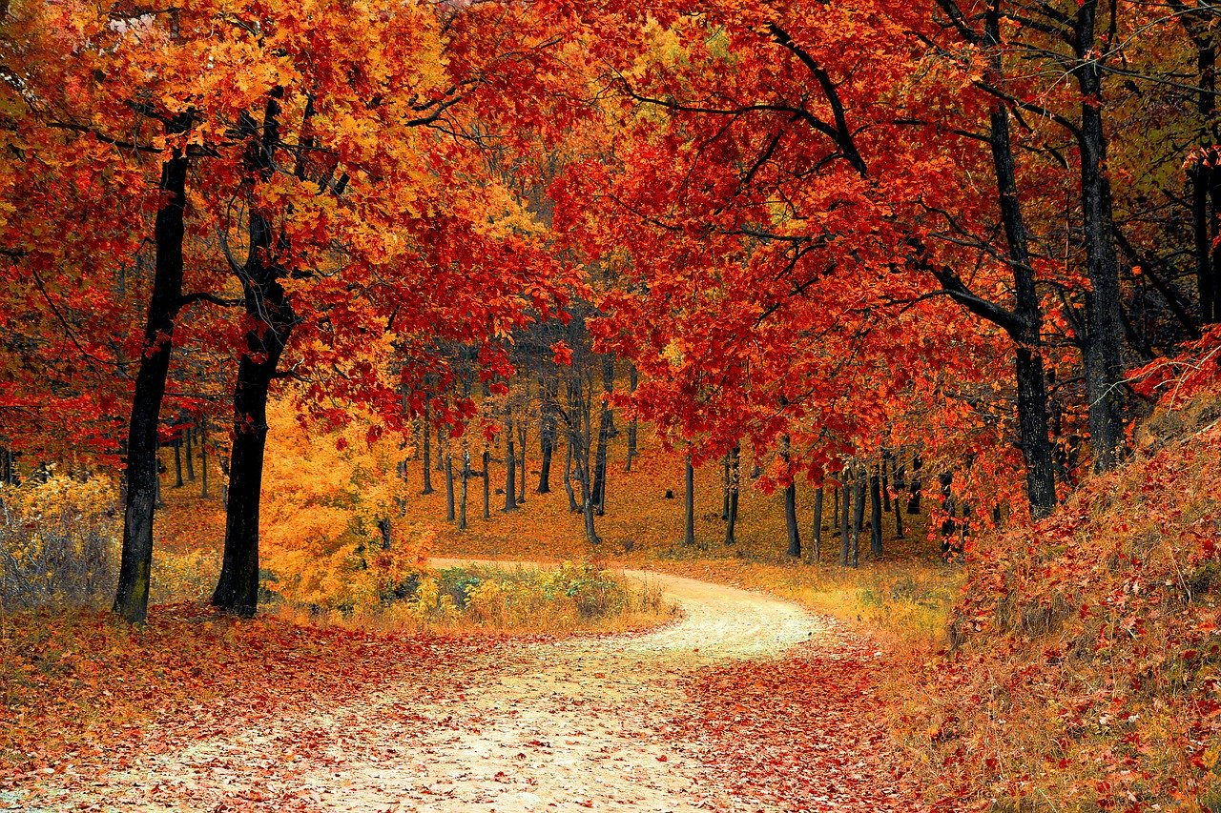

Grasslands

Grasslands are the Prairies of southern Alberta, Saskatchewan and Manitoba. The climate is very dry. Very few trees can grow in these conditions. Most trees occur in the moist river valleys Grass is abundant. The grass roots form an interlaced SOD MAT system. The mat retains moisture and prevents soil erosion. The Grassland has three regions. The very dry SHORT-GRASS PRAIRIE. The plants are drought resistant and hardy (e.g., cactus, sagebrush). This land is unsuitable for growing crops. It is grazing land for livestock. The LONG-GRASS PRAIRIE surrounds the dry short-grass region. Precipitation is sufficient for grains and oil seeds. PARKLAND is the transition between the prairie and the Boreal Forest. The vegetation is a mix of small trees and grasses.

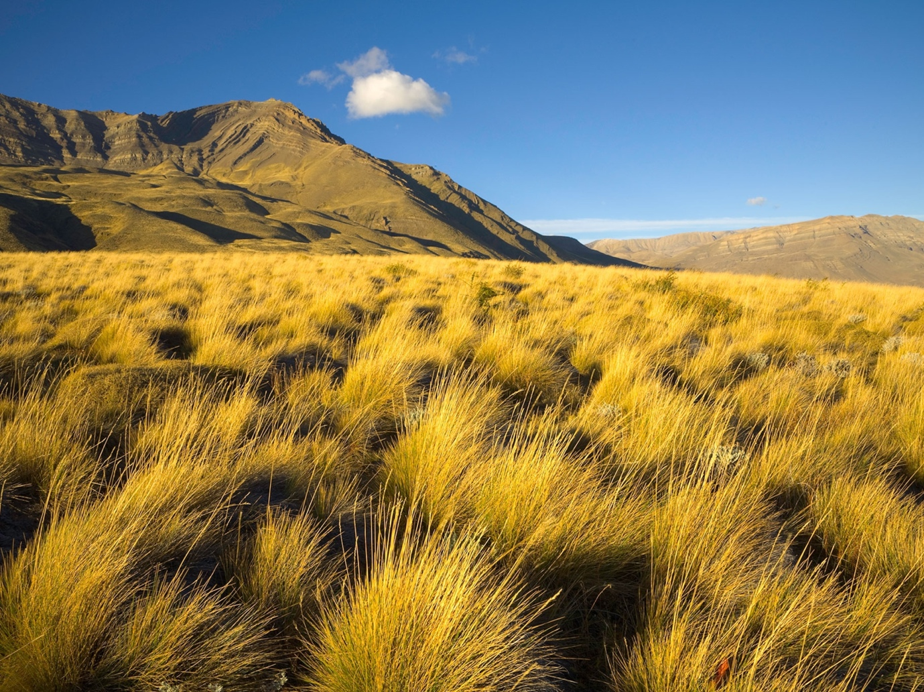

Cordilleran Vegetation

In this region, temperature decreases with increasing elevation. As well, rainfall occurs on the windward side of the mountains, while the leeward side is dry. Consequently, vegetation varies. The dry, hot valleys are grasslands or semi-deserts. Higher in the mountains, the vegetation is coniferous trees. Above the tree line, only small flowers and shrubs grow. At the tops of the mountain, no vegetation grows. Soil type depends on elevation, slope, rainfall and vegetation cover.

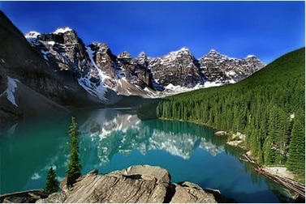

West Coast Forest

The climate in this region is very mild and very wet. As a result, lush forests grow. This region is a TEMPERATE RAINFOREST. Tress include the Douglas fir, Sitka spruce and red cedar. The trees grow to more than 1 m in diameter and 50 m in height. The vegetation provides a lot of material for humus, but the high rainfall leaches the minerals deep into the ground.

