SCHOOL LOGO

FINAL EXAM

Name of Course: Canadian Geography Teacher:

Course Code: CGC1D Length of Exam:1 hour 45 mins

Date: Pages: 8

Name of Student:_________________________

|  |
| --- |
| Instructions  - Read the entire exam thoroughly before you begin and follow the instructions given for each section.  - This exam has five sections and is worth 10% of the overall course mark.  - Remember that the number of marks per question should guide the amount of time spent answering it.  - Plan your time carefully and make sure to review all of your answers before handing in the exam.  - Cheating and/or talking will result in a mark of zero (0).  - Necessary items: Demographic Calculations Cheat Sheet and non-programmable calculator |

**Time Breakdown**

|  |  |  |
| --- | --- | --- |
| **Section** | **Number of Questions** | **Estimated Time** |
| Part I: Map of Canada | **2** | **10 mins** |
| Part II: Fill in the Blanks/Definitions | **6** | **10 mins** |
| Part III: Short Answer (Communication) | **4** | **25 mins** |
| Part IV: Short Answer (Application) | **5** | **30 mins** |
| Part V: Short Answer (Inquiry) | **2** | **30 mins** |

**Mark Breakdown**

|  |  |  |
| --- | --- | --- |
| Knowledge / Understanding |  | **/25** |
| Thinking / Inquiry |  | **/13** |
| Communication |  | **/15** |
| Application |  | **/15** |
| **Total Marks** |  | **/68** |

**Part I: Map of Canada (Knowledge and Understanding)**

/15 marks

Suggested Time: 10 minutes

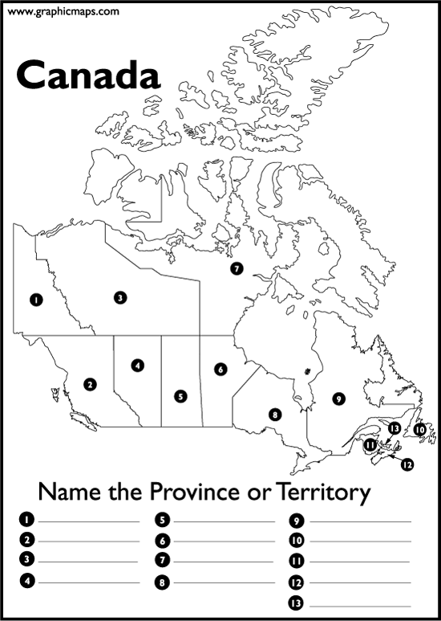

**Name two basic map features this map is missing. (2 marks)**



**Write the name of the territory or province that corresponds to each number. (13 marks)**

1. _____________________________
2. _____________________________
3. _____________________________
4. _____________________________
5. _____________________________
6. _____________________________
7. _____________________________
8. _____________________________
9. _____________________________
10. _____________________________
11. _____________________________
12. _____________________________
13. _____________________________

**Part II: Fill in the Blanks (Knowledge and Understanding)**

/10 marks

Suggested Time: 15 minutes

1. The capital city of Prince Edward Island is _________________________________. (1 mark)
2. The capital city of Alberta is ____________________________________. (1 mark)
3. _____________________________ is the movement of goods, people, and ideas among different countries around the world. (1 mark)
4. Two reasons why Canadians use the most energy per capita in the world are: (2 marks)

* __________________________________________________________________
* __________________________________________________________________

1. What is population density? (1 mark) _______________________________________________________________________
2. Choose **four (4)** of the following terms, and then provide a complete definition for each. Rewrite the word on the line or indicate in the box which words you are defining. (4 marks)

Prime Meridian Pangaea Convergent plate boundary

Doubling Time Push Factor Human Development Index

Ecological Footprint Brain Drain Divergent plate boundary

Sediment Demography Sparse population density

1. _____________________________________________________________________

__________________________________________________________________________________________________________________________________________

1. _______________________________________________________________________________________________________________________________________________________________________________________________________________
2. _______________________________________________________________________________________________________________________________________________________________________________________________________________
3. _______________________________________________________________________________________________________________________________________________________________________________________________________________

**Part III: Short Answer (Communication)**   
Suggested Time: 25 minutes

/ 15 marks

*Answer the following questions in full sentences with correct spelling and grammar.*

1. Explain the difference between climate and weather. (2 marks)
2. Describe six factors which influence the location of a settlement. (3 marks)
3. Explain the difference between primary, secondary, and tertiary industries. Give an example for each type of industry. (6 marks)
4. Explain the difference between a renewable and a non-renewable energy source. Give an example of a Canadian resource of each type. (4 marks)

**Part IV: Short Answer (Application)**

/ 15 marks

Suggested Time: 30 minutes

1. Provide **two** reasons to explain why developing countries rely on agricultural economies as their main industry. (2 marks)
2. Do you think Canada should allow more immigration? Create a comic strip below to express your opinion. Include both picture and captions and be creative! (4 marks)

_________________________________________

_________________________________________

_________________________________________

_________________________________________

_________________________________________

_________________________________________

_________________________________________

_________________________________________

_________________________________________

_________________________________________

_________________________________________

_________________________________________

1. What is sustainability? Devise **three** realistic suggestions for how you can act more sustainably in your own life. (4 marks)
2. Use the following statistics to determine the emigration rate for Portugal. Include a final statement. (2 marks)

**Total Population**: 10,825,309

**Emigrants in 2015**: 297,416

1. Use the population pyramid below to answer the following questions.

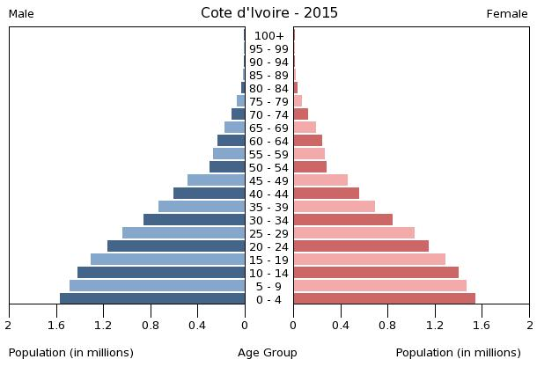

1. What type of population pyramid does this represent? (1 mark)
2. What do you notice about the dependency load vs. working age group? (2 marks)

**Part V: Short Answer (Thinking/Inquiry)**

/ 13 marks

Suggested Time: 30 minutes

1. Imagine that you are a tourist visiting Canada. Choose **one** landform region and write a postcard to a friend explaining: **the physical landforms, the climate, and the human activities.** Draw relevant images on the front side of the postcard. (8 marks)

Landform Regions of Canada include: Western Cordillera, Interior Plains, Canadian Shield, Hudson Bay and Arctic Lowlands, Great Lakes and St. Lawrence Lowlands, Appalachian Mountains, and the Innuitian Mountains.

Postcard front (images): (2 marks)

Postcard reverse side (text to a friend): (6 marks)

1. Compare and contrast the following two climate graphs by answering the questions provided.

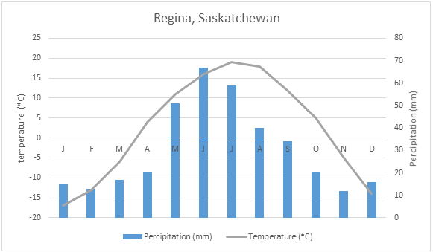

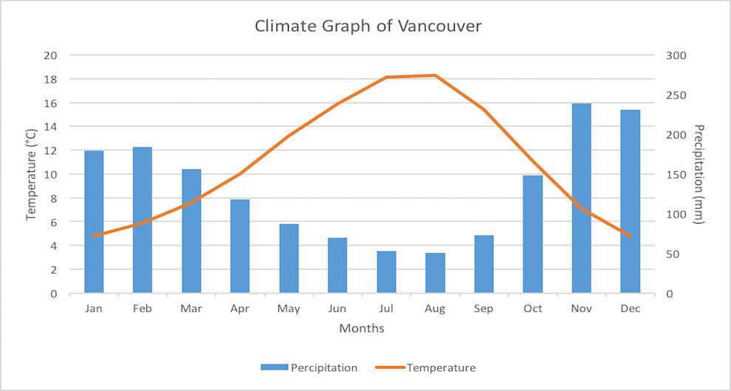

1. Is Regina a continental or maritime climate? (1 mark)
2. Referring to the climate, show **two** similarities between these graphs. (2 marks)
3. Referring to the climate, show **two** differences between these graphs. (2 marks)