SCHOOL LOGO

FINAL EXAM

Name of Course: Canadian Geography Teacher:

Course Code: CGC1D Length of Exam:1 hour 45 mins

Date: Pages: 8

Name of Student:_________________________

|  |
| --- |
| Instructions  - Read the entire exam thoroughly before you begin and follow the instructions given for each section.  - This exam has five sections and is worth 10% of the overall course mark.  - Remember that the number of marks per question should guide the amount of time spent answering it.  - Plan your time carefully and make sure to review all of your answers before handing in the exam.  - Cheating and/or talking will result in a mark of zero (0).  - Necessary items: Demographic Calculations Cheat Sheet and non-programmable calculator |

**Time Breakdown**

|  |  |  |
| --- | --- | --- |
| **Section** | **Number of Questions** | **Estimated Time** |
| Part I: Map of Canada | **2** | **10 mins** |
| Part II: Fill in the Blanks/Definitions | **6** | **10 mins** |
| Part III: Short Answer (Communication) | **4** | **25 mins** |
| Part IV: Short Answer (Application) | **5** | **30 mins** |
| Part V: Short Answer (Inquiry) | **2** | **30 mins** |

**Mark Breakdown**

|  |  |  |
| --- | --- | --- |
| Knowledge / Understanding |  | **/25** |
| Thinking / Inquiry |  | **/13** |
| Communication |  | **/15** |
| Application |  | **/15** |
| **Total Marks** |  | **/68** |

**Part I: Map of Canada (Knowledge and Understanding)**

/15 marks

Suggested Time: 10 minutes

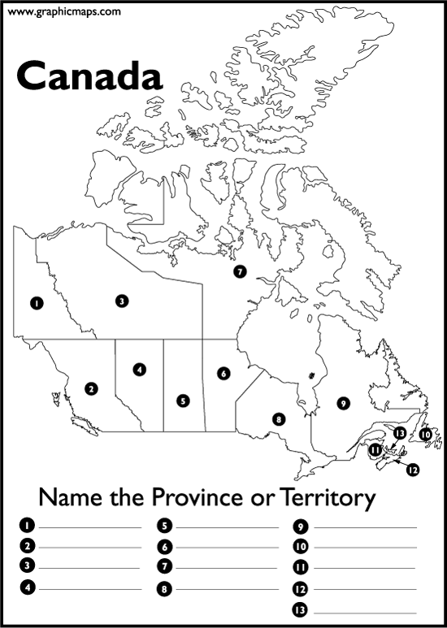

**Name two basic map features this map is missing. (2 marks)**

* Scale
* Compass

**Write the name of the territory or province that corresponds to each number. (13 marks)**

1. Yukon
2. British Columbia
3. North West Territories
4. Alberta
5. Saskatchewan
6. Manitoba
7. Nunavut
8. Ontario
9. Quebec
10. Newfoundland and Labrador
11. New Brunswick
12. Nova Scotia
13. PEI

**Part II: Fill in the Blanks (Knowledge and Understanding)**

/10 marks

Suggested Time: 15 minutes

1. The capital city of Prince Edward Island is Charlottetown. (1 mark)
2. The capital city of Alberta is Edmonton. (1 mark)
3. Globalisation is the movement of goods, people, and ideas among different countries around the world. (1 mark)
4. Two reasons why Canadians use the most energy per capita in the world are: (2 marks)

* High income country
* Large land area
* Cold areas
* Materialistic (Americanisation)

1. What is population density? (1 mark) The amount of people living per km2.
2. Choose **four (4)** of the following terms, and then provide a complete definition for each. Rewrite the word on the line or indicate in the box which words you are defining. (4 marks)

Prime Meridian Pangaea Convergent plate boundary

Doubling Time Push Factor Human Development Index

Ecological Footprint Brain Drain Divergent plate boundary

Sediment Demography Sparse population density

Prime Meridian - The earth's zero of longitude, which by convention passes through Greenwich, England.

Pangaea - a supercontinent that existed during the late Paleozoic and early Mesozoic eras.

Convergent plate boundary - where two or more lithospheric plates collide.

Doubling Time - the time it takes for a population to double in size/value.

Push Factor – a reason for people to leave (migrate away from) an area.

Human Development Index – A statistic composite index of life expectancy, education, and per capita income indicators, which are used to rank countries into four tiers of human development.

Ecological Footprint - the impact of a person or community on the environment, expressed as the amount of land required to sustain their use of natural resources.

Brain Drain - the migration of health personnel in search of the better standard of living and quality of life, higher salaries, access to advanced technology and more stable political conditions in different places worldwide.

Divergent plate boundary - where two or more lithospheric plates divide.

Sediment - naturally occurring material that is broken down by processes of weathering and erosion,

Demography – study of population.

Sparse population density – few people living per km2.

**Part III: Short Answer (Communication)**   
Suggested Time: 25 minutes

/ 15 marks

*Answer the following questions in full sentences with correct spelling and grammar.*

1. Explain the difference between climate and weather. (2 marks)

**Weather** refers to short term atmospheric conditions while **climate** is the **weather** of a specific region averaged over a long period of time.

1. Describe six factors which influence the location of a settlement. (3 marks)

Climate

Terrain

Water sources

Availability of natural resources

Transport links

Defences

Fertile land

Route centre

1. Explain the difference between primary, secondary, and tertiary industries. Give an example for each type of industry. (6 marks)

Primary industry involves getting raw materials e.g. mining, farming and fishing.

Secondary industry involves manufacturing e.g. making cars and steel.

Tertiary industries provide a service e.g. teaching and nursing.

Quaternary industry involves research and development industries e.g. IT.

1. Explain the difference between a renewable and a non-renewable energy source. Give an example of a Canadian resource of each type. (4 marks)

* A non-renewable resource is a natural resource that cannot be readily replaced by natural means at a pace quick enough to keep up with consumption. An example is carbon-based fossil fuels such as oil, natural gas and coal.
* A renewable resource, also known as a flow resource, is a natural resource which will replenish to replace the portion depleted by usage and consumption, either through natural reproduction or other recurring processes in a finite amount of time in a human time scale. Eg. Wind, solar, geothermal, HEP.

**Part IV: Short Answer (Application)**

/ 15 marks

Suggested Time: 30 minutes

1. Provide **two** reasons to explain why developing countries rely on agricultural economies as their main industry. (2 marks)

* Abundance of natural resources
* Lack of technically skilled labour and education for tertiary industry
* Lack of machinery/capital for secondary industry
* Lack of communications for quaternary industry

1. Do you think Canada should allow more immigration? Create a comic strip below to express your opinion. Include both picture and captions and be creative! (4 marks)

Answers will vary

1. What is sustainability? Devise **three** realistic suggestions for how you can act more sustainably in your own life. (4 marks)

Sustainability is the capacity to endure in a relatively ongoing way across various domains of life. In the 21st century, it refers generally to the capacity for Earth's biosphere and human civilization to co-exist.

* Save energy. By using less energy, you can help to reduce carbon emissions. ...
* Eat less meat. ...
* Use reusable alternatives. ...
* Go paperless. ...
* Use renewable energy. ...
* Recycle and reuse. ...
* Grow your own produce. ...
* Donate unused items.
* Save water
* Drive less
* Buy fair trade
* Don’t waste food
* Buy sustainable clothing
* Use eco-friendly products.

1. Use the following statistics to determine the emigration rate for Portugal. Include a final statement. (2 marks)

**Total Population**: 10,825,309

**Emigrants in 2015**: 297,416

Emigration rate = Mi/(Mi+Ni)

297,416/297,416+10,825,309

= 297,416/11,122,725

= 0.027 x 100

= 2.7

1. Use the population pyramid below to answer the following questions.

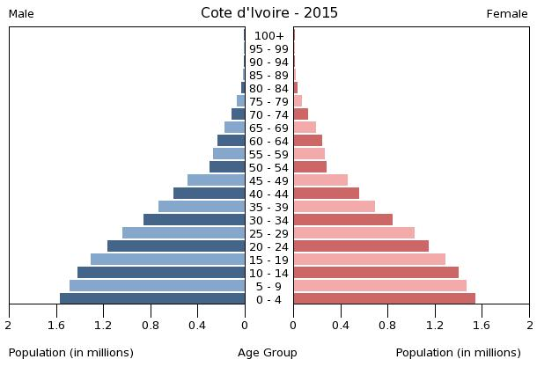

1. What type of population pyramid does this represent? (1 mark)

Expanding

1. What do you notice about the dependency load vs. working age group? (2 marks)

Dependency load is much greater than work age group.

*Use of statistics will vary

**Part V: Short Answer (Thinking/Inquiry)**

/ 13 marks

Suggested Time: 30 minutes

1. Imagine that you are a tourist visiting Canada. Choose **one** landform region and write a postcard to a friend explaining: **the physical landforms, the climate, and the human activities.** Draw relevant images on the front side of the postcard. (8 marks)

Landform Regions of Canada include: Western Cordillera, Interior Plains, Canadian Shield, Hudson Bay and Arctic Lowlands, Great Lakes and St. Lawrence Lowlands, Appalachian Mountains, and the Innuitian Mountains.

Answers will vary

1. Compare and contrast the following two climate graphs by answering the questions provided.

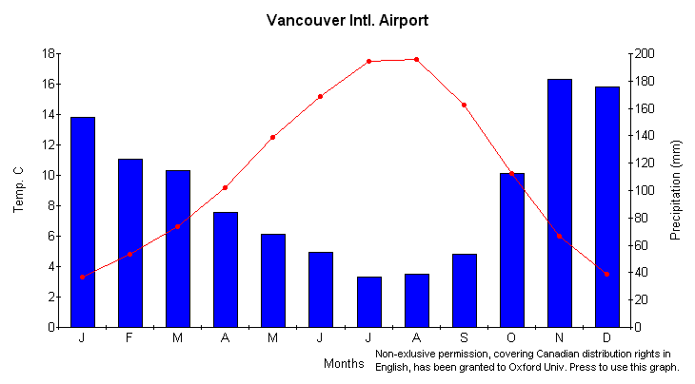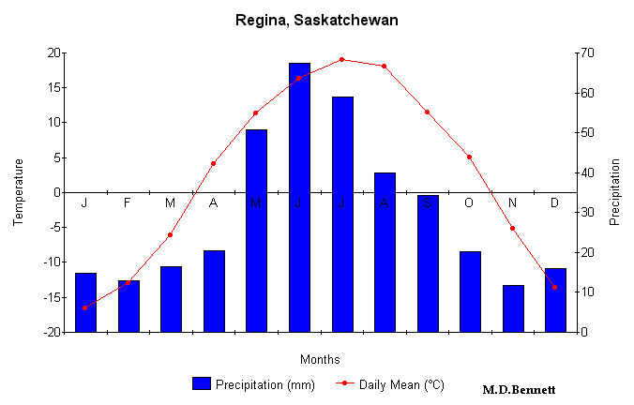

1. Is Regina a continental or maritime climate? (1 mark)

Continental climate

1. Referring to the climate, show **two** similarities between these graphs. (2 marks)

* Both see higher temperatures during summer months and lower temperatures during winter months (same shape) – credit accurate use of statistics to support answer
* Precipitation is variable throughout the year.
* Temperature is variable throughout the year

1. Referring to the climate, show **two** differences between these graphs. (2 marks)

* credit accurate use of statistics to support answers
* Regina larger temperature range than Vancouver
* Vancouver larger precipitation range than Regina
* Regina hotter and colder on average (continental climate)
* Vancouver more consistent temperatures
* Regina highest precipitation from May-August
* Vancouver highest precipitation from Oct-March.