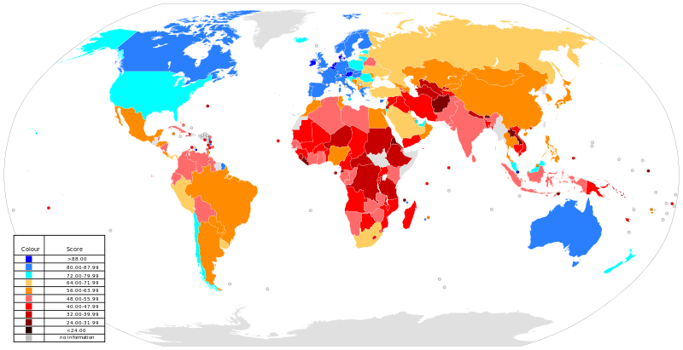
Figure 1: Choropleth Map to show rankings from the KOF Index of globalisation in 2015. N

