SCHOOL LOGO

FINAL EXAM
Name of Course: Canadian World Issues Teacher:
Course Code: CGW4U Length of Exam: 2 hours
Date: Pages: 10

Name of Student: _________________________

Instructions
- Read the entire exam thoroughly before you begin and follow the instructions given for each section.

- This exam has four sections and is worth 15% of the overall course mark.

- Remember that the number of marks per question should guide the amount of time spent answering it.

- Plan your time carefully and make sure to review all of your answers before handing in the exam.

- Cheating and talking will result in a mark of zero (0).

Mark Breakdown

Knowledge / Understanding |  | /38
Thinking / Inquiry |  | /20
Application |  | /22
Communication |  | /15
Total Marks |  | /95

KNOWLEDGE (38 Marks)

Multiple choice (20 marks)

1. What population level did the world reach in 2011?
A. 4 billion B. 5 billion C. 6 billion D. 7 billion

2. Which type of globalization is best represented by the following statement: "Eventually, most people in the world will watch the same television shows and movies"?
A. Cultural B. Political C. Sociological D. Technological

3. Which of the following is NOT measured by the HDI?
A. Education B. Life Expectancy C. GNI D. Death rates

4. Geopolitics can best be defined as
- the interplay of politics and geography at the national or international level.
- the effect geography has on a nation’s political system.
- politics played at the highest level.
- geographical issues that affect all of our lives.

5. Which country has had the greatest number of terrorist attacks to date?
A. Iraq B. Iran C. Pakistan D. Afghanistan

6. In the 21st Century, where are the greatest number of conflicts expected to occur?
A. Africa B. Asia C. Europe D. Middle East

7. How many Global Goals are there?
  - 15
  - 16
  - 17
  - 18

8. Which event in 1968 marked the beginning of modern terrorism?
- Air India flight from Vancouver was bombed
- bomb placed in World Trade Center garage
- Palestinians hijacked an Israeli airliner over Lockerbie in Scotland
- Tourists attacked by gunmen in Egypt

9. The single largest form of public spending by nations of the world is on:
A. economic development B. military C. protecting the environment D. social programs

10. What does DTM stand for?
A. Demographic Transition Model B. Demography Time Motion C. Demographic Turbulence Model D. Demographic Timeline Model

11. Considering a population pyramid, the left-hand side of pyramid is used to show:
- female population C. birth rate
- male population D. mortality rate

12. The number of deaths under 1 years old that take place per 1000 people per year is called
- infant mortality rate B. death rate C. child mortality rate D. baby mortality rate

13. If number of deaths are more than number of births then the
A. population unchanged B. population increases C. population decreases D. population remains stable

14. Canada is in which stage of demographic transition?
A. stage 2 B. stage 3 C. stage 4 D. stage 5

15. Which type of migration is said to occur when people have little or no choice but to move?
A. mass migration B. free migration C. nomadic migration D. forced migration

16. Which of the following is a barrier to migration?
A. language B. economic security C. public welfare D. persecution

17. In E.S. Lee’s model the stage between origin and destination is:
A. intervening obstacles B. intermediate obstacles C. interminable obstacles D. intermittent obstacles

18. A disease which is prevalent in a particular locality is known as:
A. pandemic B. prodemic C. endemic D. epidemic

19. A disease which is prevalent world-wide is known as:
A. pandemic B. prodemic C. endemic D. epidemic

20. Which of the following is NOT a type of pathogen.
A. bacteria B. Protists C. Fungi D. Animals

Define and state the significance (16 marks)

Select one term or concept from each column. Define the term and state, with examples, how this relates to world issues.

List 1 | List 2 | List 3 | List 4
Population explosion | Global Goals | Communicable diseases | Cultural Exceptionalism
Thomas Malthus | Lorenz Curve | Water scarcity | Terrorism
Infant Mortality Rate | UN | Production Hotspot | Hard power
Migration | HDI | Water Index | Chokepoint

List 1: Word: _________________

________________________________________________________________________________________________________________________________________________________________________________________________________________________________________________________________________
________________________________________________________________________________________________________________________________________________________________________________________________________________________________________________________________________________________________________________________________________________________________________________________________________________________________________________________________________________________________________________________________________________

List 2: Word: _________________

________________________________________________________________________________________________________________________________________________________________________________________________________________________________________________________________________
________________________________________________________________________________________________________________________________________________________________________________________________________________________________________________________________________________________________________________________________________________________________________________________________________________________________________________________________________________________________________________________________________________

List 3: Word: _________________

________________________________________________________________________________________________________________________________________________________________________________________________________________________________________________________________________
________________________________________________________________________________________________________________________________________________________________________________________________________________________________________________________________________________________________________________________________________________________________________________________________________________________________________________________________________________________________________________________________________________

List 4: Word: _________________

________________________________________________________________________________________________________________________________________________________________________________________________________________________________________________________________________
________________________________________________________________________________________________________________________________________________________________________________________________________________________________________________________________________________________________________________________________________________________________________________________________________________________________________________________________________________________________________________________________________________
APPLICATION (22 Marks)

1. The figure below shows a series of population pyramids for Iran.

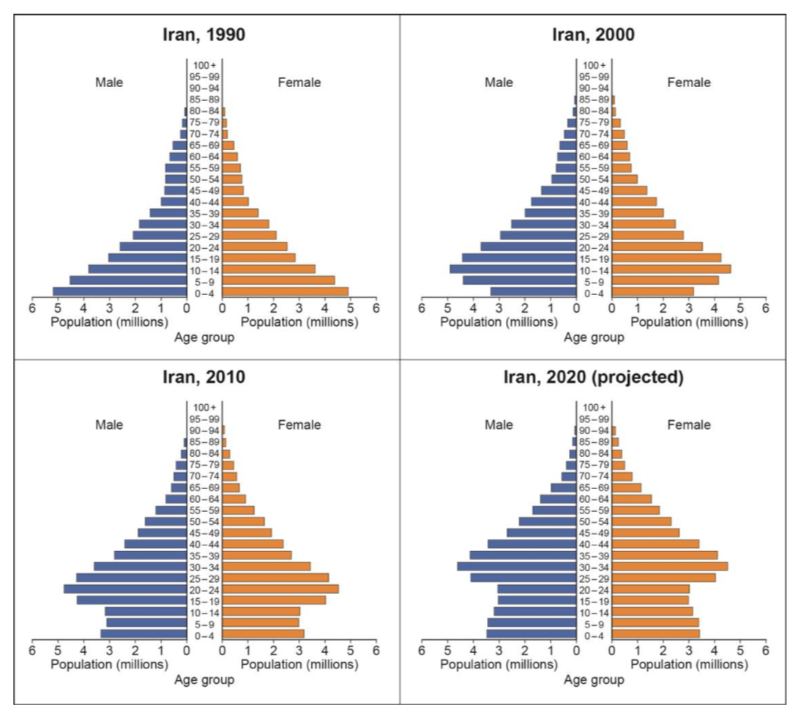

Analyse the trends illustrated in the population pyramids for Iran. (6)

2. Below is a map showing countries of origin of asylum seekers in the European Union in 2014.

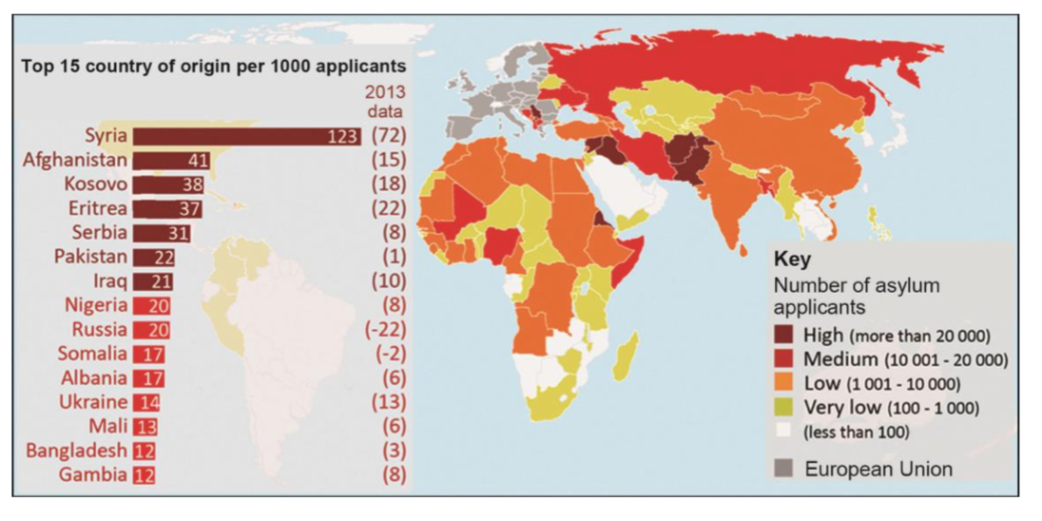

Assess the factors that might account for the spatial variation shown in the map above. (7)

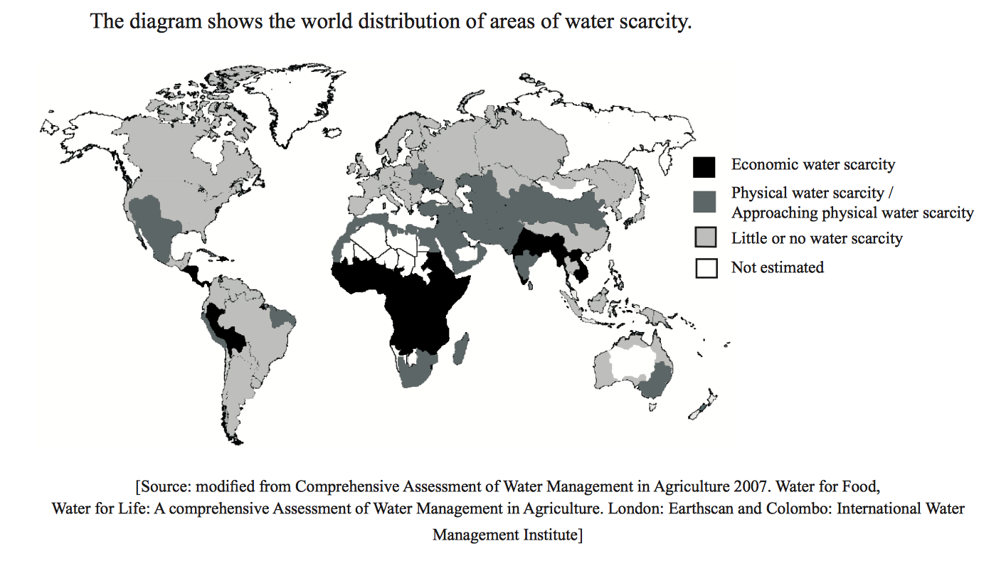

3. Using evidence from the map above, describe the global distribution of water scarcity. (4)

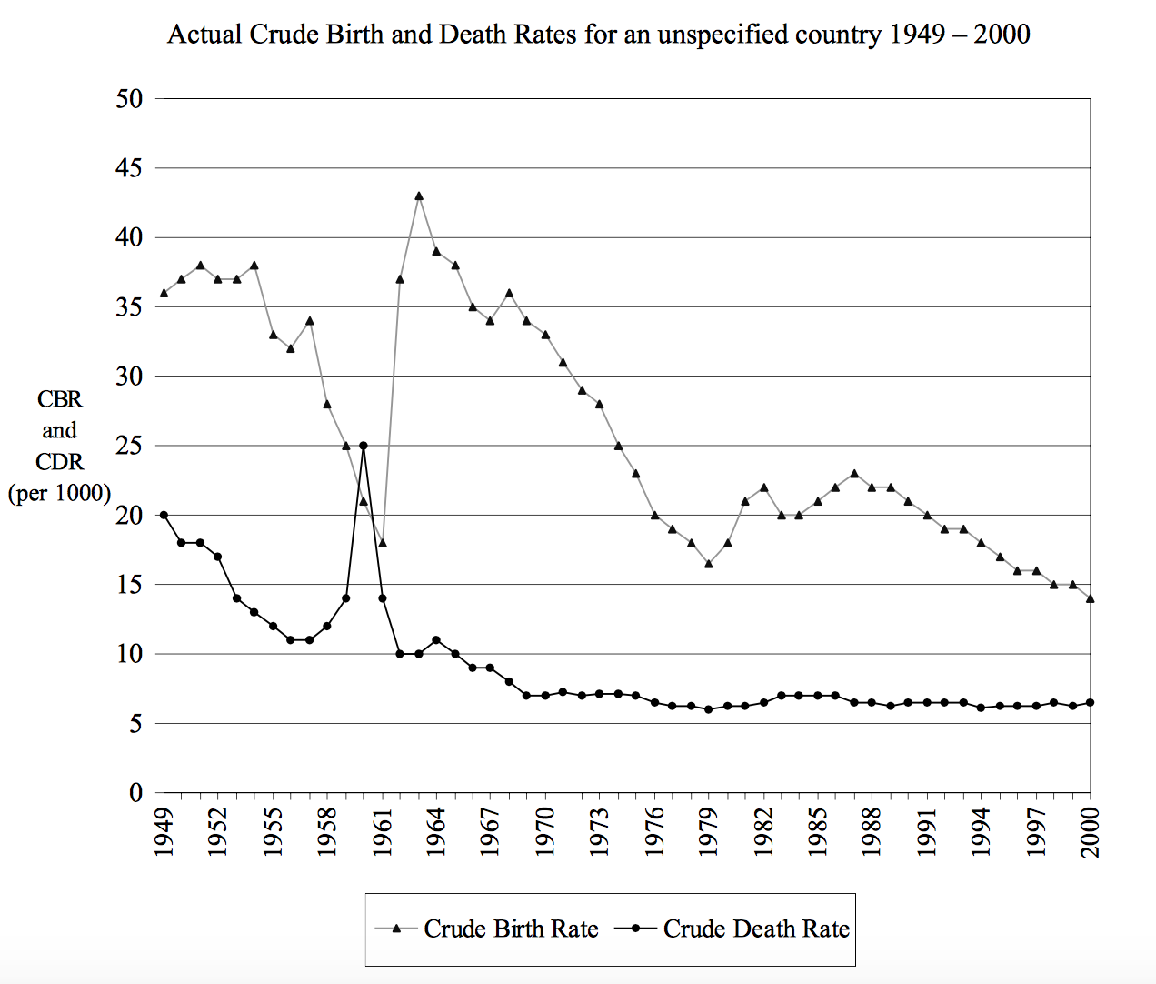

Use the information from the graph above to answer the following questions.

4a. Define crude birth rate. (1)

____________________________________________________________________________________________________________________________________

4b. State the year when the rate of population growth is greatest, and then calculate the rate and explain briefly how this was done. (3)

THINKING (20 Marks)

Answer FOUR of the following questions only. Your answers must be in complete sentences and in paragraph form.

*** Please write your answers on the lined paper provided. Ensure you write the correct question number next to your response.

- Describe the eight stages of genocide as identified by the UN.
- Explain four of the current Global Goals.
- Using Lee’s Model of migration outline four intervening obstacles to migration and explain how they are a barrier.
- For a country you have studied explain the push and pull factors for migration.
- Define communicable diseases, and using examples, discuss their social and economic impacts.
- Explain the two types of disease transmission diffusion and examine their importance in a globalised society.
- Define asymmetrical warfare and explain its relevance in contemporary society.
- Explain the five different types of conflict and give an example for each.
- Explain the difference between hard and soft power, refer to examples of each in your answer.
- Define the Water Poverty Index and explain how it is calculated.
- Describe and explain three physical factors affecting global energy reserves.
- Describe and explain two factors which affect energy security in a country.

COMMUNICATION (15 marks)

Thinking criteria:
Clear thesis is present
Powerful supporting arguments which are consistent with the thesis
Substantial and appropriate use of specific evidence and examples to defend arguments

Arguments and evidence are drawn from the entire course Communication criteria:
Proper essay format is used
Essay is written in complete paragraphs and proper sentences
Key terms are clearly defined
Ideas are clearly expressed and logically ordered

Using the above criteria, write an essay for ONLY ONE of the following topics.

*** Please write your answers on the lined paper provided.

- How effective has the United Nations been in preventing or intervening in genocide? Ensure you define the objectives of the United Nations, and use real life examples in your answer.

- "To achieve a sustainable future, should global population grow, decline or remain stable?"
In the form of an essay, respond to this question using evidence from the population theories discussed in class.

- For at least one location that you have studied examine the causes, and the social, economic and environmental impacts of water scarcity and/or pollution on that location.

- The development of alternative energy sources is a possible response to future energy demands. Using examples that you have studied, assess the possible costs and benefits of this approach.

