**FINAL EXAM**

Name of Course: Business Leadership Teacher:

Course Code: BOH4M Length of Exam: 120 minutes

Date: Pages: 10

Name of Student:_________________________

|  |
| --- |
| **Instructions**  - Read the entire exam thoroughly before you begin and follow the instructions given for each section.  - This exam has four sections and is worth 15% of the overall course mark.  - Remember that the number of marks per question should guide the amount of time spent answering it.  - Plan your time carefully and make sure to review all of your answers before handing in the exam.  - Cheating and/or talking will result in a mark of zero (0).  - Remember marks will be awarded for SPAG in Section D: Communication. |

**Mark Breakdown**

|  |  |  |
| --- | --- | --- |
| Knowledge / Understanding (SECTION A) |  | **/42** |
| Thinking / Inquiry (SECTION B) |  | **/16** |
| Application (SECTION C) |  | **/25** |
| Communication (SECTION D) |  | **/15** |
| **Total Marks** |  | **/98** |

**SECTION A: KNOWLEDGE (42 marks)**

Please answer all questions using the space provided.

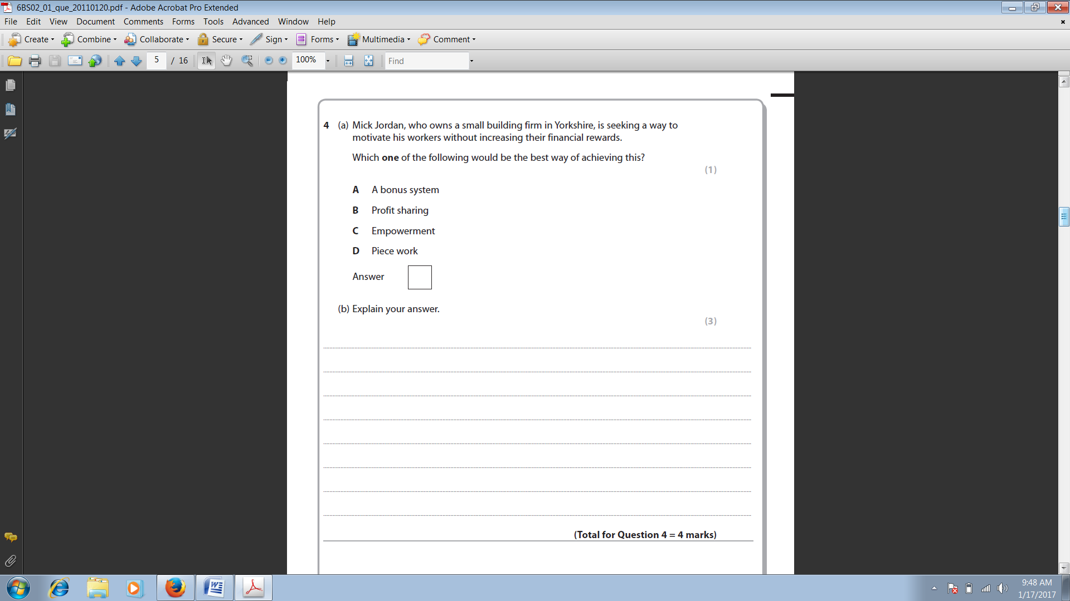

**(1)**

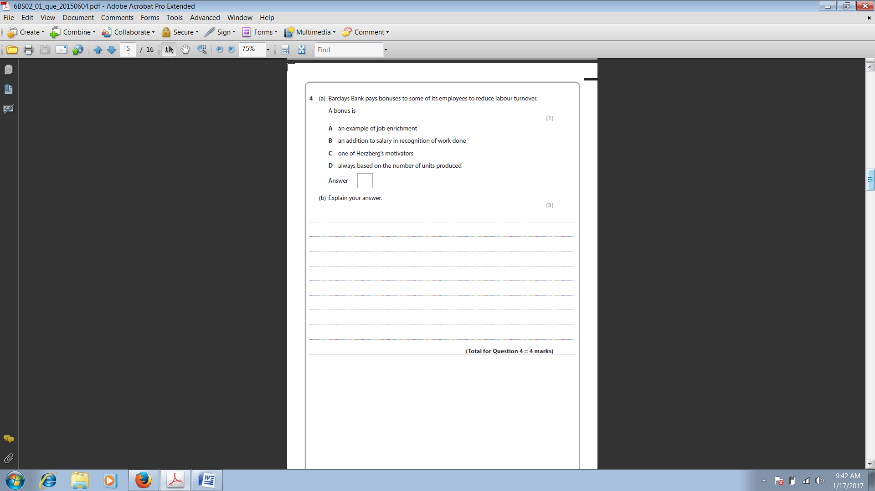

**(2)**

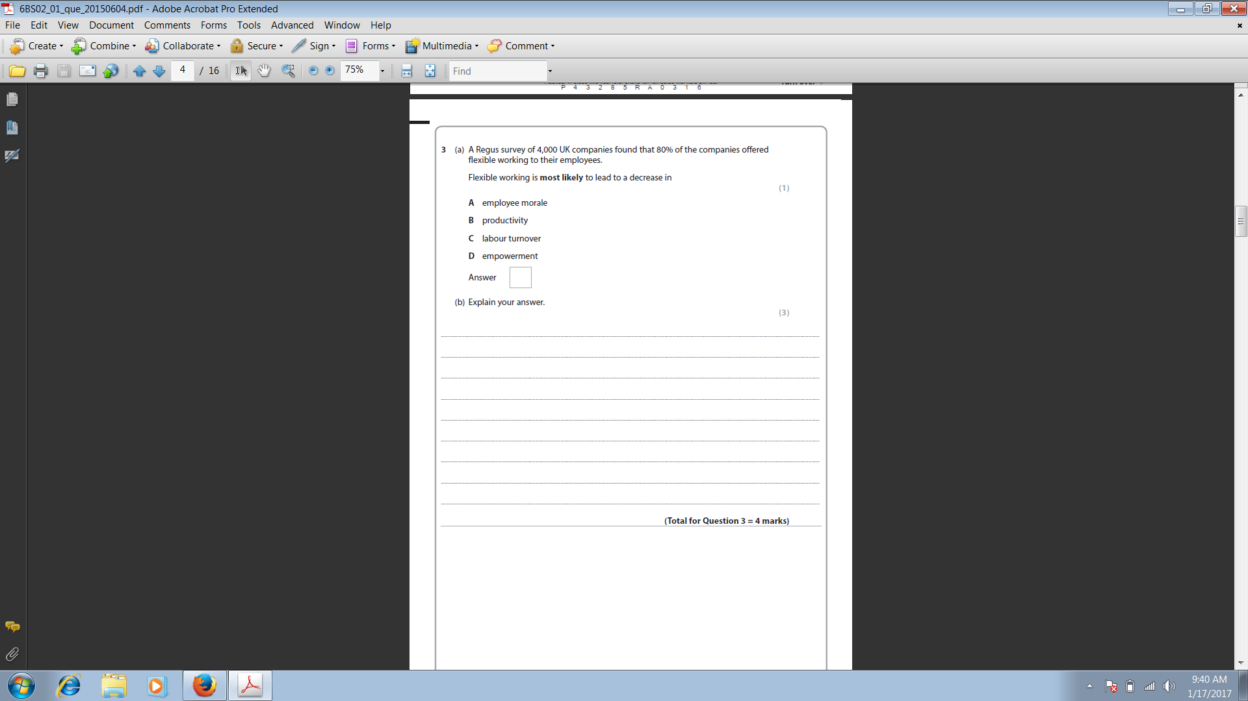

**(3)**

**(4)**

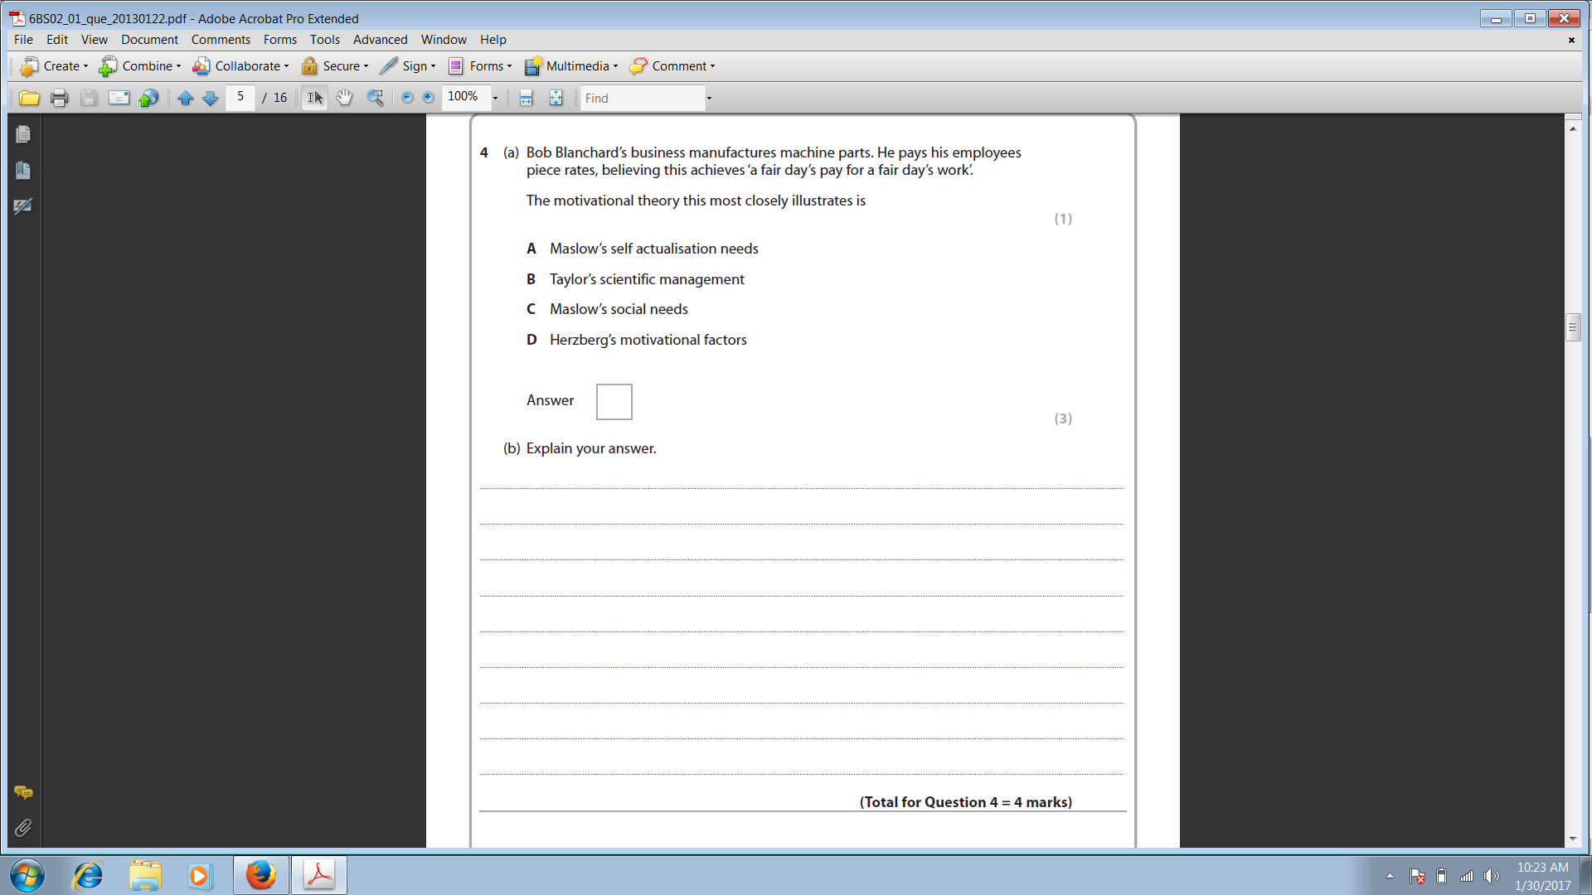

**(5)**

**6. Matching (26 marks)**

*Match the most correct word in column A to the best description in column B.*

*Place the letter(s) of the description in column B on the line in column A.*

|  |  |
| --- | --- |
| ***Column A*** | ***Column B*** |
| 1. ____ SWOT Analysis  2. ____Ethical Behaviour  3. ____Halo Effect  4. ____Autocratic Leader  5. ____Power  6. ____Frederick Taylor  7. ____Proxemics  8. ____Performance Appraisal  9. ____Porter’s Five Forces  10. ___Contract workers  11. ___ Douglas McGregor  12. ___ B.F. Skinner  13. ___ Intrinsic  14. ___ Perception  15. ___ Management functions  16. ___ Robert. L. Katz  17. ___ Globalisation  18. ___Corporate Objectives  19. ___Stereotyping  20. ___Conflict Management  21. ___Stakeholders  22. ___ Meredith Belbin  23. ___ Laissez-Faire Leader  24. ___Business vision  25. ___Proactive approach  26. ___CSR | A. The "Father of 'Scientific Management"  B. An individual's capacity to influence decisions  C. Where a business wants to be in an ideal world  D. Placing attributes associated with a specific group to an individual  E. Planning, controlling, leading, organising  F. Founder of the Operant Conditioning/Reinforcement Theory  G. Individual who has total control over all decisions  H. Behaviour that is deemed 'good' or 'right' by society  I. Concept of a boundary-less world where everyone is interconnected  J. Author of the Team Role Theory.  K. Avoidance, smoothing, competition, compromise, collaboration  L. People who are hired for fixed-term, specific job roles  M. A framework for analysing the nature of competition within an industry  N. These concern the business as a whole. Eg: $20 million profit  O. Motivation that comes from within, such as dreams and belief  P. When one attribute is used to develop an overall impression  Q. A method by which job performance is evaluated and recorded  R. A 'Hands-off' approach to management  S. A company that takes leadership in social initiatives for CSR  T. The interpretation of what we take in through our senses  U. A way to improve communication in the workplace  V. The obligation of a business to act in a responsible manner  W. Idea of 3 essential managerial skills: conceptual, technical, human  X. Founder of the X and Y Theory  Y. Any individual or group that may be affected by a business  Z. Strengths, weaknesses, opportunities and threats audit. |

**SECTION B: THINKING (16 marks)**

***Read the following case study and then answer the following questions in the space provided. Make sure to use complete sentences.***

**HBC: From Fur to Fendi**

After 300 years, Canada's oldest retailer knows a thing or two about change. Older than the country it serves, Hudson's Bay Company (HBC) has remained a landmark institution in Canada, navigating its way from rural outposts to over 600 locations and nearly 60,000 associates located in every province in Canada. Known best for its flagship department store The Bay, HBC currently also operates additional retailers Home Outfitters.

Despite its long and glorious past, all is not well at Canada's historic company. Leadership changes, increased competition, a fragmenting retail market, and plummeting sales have plagued HBC well into the new millennium. Will HBC be able to successfully weather the seas of change or will it sink into history?

**HISTORY**

Two centuries before Confederation, a pair of European explorers discovered a wealth of fur in the interior of Canada accessible by an inland sea, Hudson’s Bay. In 1670, with per- mission from the King of England, trading began and the first century found HBC trading goods and furs in a few forts and posts around the James and Hudson Bays. Later, competi- tion forced HBC to expand into Canada’s interior and a string of outposts grew up along river networks that would eventually become the modern cities of Winnipeg, Calgary, and Edmonton.

By the end of the 19th century, changing tastes caused the fur trade to lose importance, while western settlements and the gold rush quickly introduced new clientele to HBC—ones who paid in cash, not fur. Trading posts began to give way to sales shops with a greater selec- tion of goods, transforming HBC into a modern retail organization. During this time, HBC also started selling homesteads to newly arrived settlers, eventually diversifying into a full- scale commercial property holding and development organization. Shipping and natural resources, particularly oil and gas, were important sidelines.

**CHALLENGES**

Flash forward to the 1980s. The pace of HBC’s retail acquisition and the economic downturn left The Bay with major debt and caused HBC to rethink its priorities. Like many other firms at the time, HBC decided to return to its core business. Non-strategic assets were sold, as were the company’s last natural resource holdings. Strategic expansion followed to strengthen its share of the market with the acquisition of other retailers, such as K-Mart Canada.

Since the 1980s, the company has continued to navigate its way through the wake of a weakened economy, changing consumer tastes, and intense competition. The popularity of big-box stores, such as Old Navy, Future Shop, and Walmart, have changed consumer behav- iour away from department store shopping, forcing retailers like The Bay to compete on selec- tion of merchandise and price.

With its reputation for unfocused collections of merchandise, shabby stores, and unhelpful sales staff, HBC tried a number of strategies to entice customers back to its stores. Some strategies, such as the HBC Rewards program and online shopping, have been successful; however, other strategies haven’t fared as well. Early in 2001, it tried to reinvent itself with a more fashionable image for The Bay, and it reduced the focus on steep discounts. The economy and frustrated customers forced it to abandon the move and return to its value-based focus. To try to remain competitive with other low-cost retailers, HBC diversified, although unsuccessfully, through Designer Depot/Style Depot, which operated from 2004 to 2008.

After remaining a Canadian company for over 330 years, HBC was bought in 2006 by U.S. financier Jerry Zucker, who sought to revive the firm by focusing on improving operations and customer satisfaction. In 2008, after Zucker’s death, HBC was bought by U.S. private equity firm NRDC Equity Partners. NRDC’s strategy was once again to revitalize HBC with better brands and better service.

Under NRDC’s leadership, The Bay quickly focused on re-attracting customers by dropping over 60 percent of its former brands and relaunching “The Room,” a plush VIP suite at one of its Toronto locations, with high-end designers such as Armani, Ungaro, and Chanel. Despite the economic downturn in 2008 and the resulting layoffs, The Bay was in the black.

Another coup for HBC was becoming an official sponsor for the 2010 Olympics in Vancouver. Now that it was official outfitter of the Canadian Olympic team and exclusive supplier of Olympic-branded merchandise, new customers and those who hadn’t shopped at The Bay in years flocked back to The Bay to snap up hoodies, coats, hats, and the iconic red mittens as fast as staff could put the merchandise on the shelves.

HBC will try to repeat its current successes by introducing new products, redesigning stores, and launching “The Room” in other major cities. In particular, it hopes to bring customers back by capitalizing on its Canadian history by redesigning its Signature Line, addinga modern twist to HBC classics such as its striped “point” blankets, sweaters, coats, canoes, trapper hats, and maple syrup, reminiscent of its early trading days.

Based on its recent successes, HBC seems to be on the right track, but will it be enough to make it once again a premier Canadian shopping destination or is it too late to revive the historic department store?

**QUESTIONS**

1. Create either a SWOT **or** PEST analysis for HBC. [8]
2. Using Porter’s Five Forces model create an analysis of HBC.
   1. What does the five forces model reveal about the industry that HBC competes within? [5]
   2. What are its strategic implications for HBC? [3]

***\*\*\*Complete the above questions on a separate piece of paper.***

**SECTION C: APPLICATION (25 Marks)**

*Answer* ***FIVE*** *of the following questions.* ***Each question is worth 5 marks****. Make sure you use complete sentences and watch your spelling and grammar. Write your answers to these questions on the lined sheets provided.* ***Ensure that you write the question number you have answered next to your response.***

1. Explain the levels of Maslow's Hierarchy of needs. Support you answer by referring to how a manager can directly apply these needs relative to his/her employees. You may use a diagram in your response. (5)

2. Explain the four functions of management. Relate how these functions are performed in an organisation of your choice. (5)

3. Explain the five stages of Tuckman's Team Development theory. Relate how these stages worked when you were a member of the Escape Rooms team for your ISU. (5)

4. Discuss the six challenges that managers face when working in the 21st Century workplace. (5)

5. Explain Katz's theory of essential managerial skills, and how these skills vary depending on the level of the manager. You may use a diagram in your answer. (5)

6. Describe the 'BIG FIVE' personality traits and how they may be a positive and negative influence in the workplace. (5)

7. Explain the three types of strategic planning. Use examples of how each one might be used in a business. (5)

8. Explain the five sources of leadership power. (5)

9. What are SMART Objectives? Describe each step and give an example of each. (5)

10. What is a PEST analysis? Describe what it is and give a hypothetical example. (5)

**SECTION D: COMMUNICATION (15 marks)**

Thinking criteria:

* + - Clear thesis is present
    - Powerful supporting arguments which are consistent with the thesis
    - Substantial and appropriate use of specific evidence and examples to defend arguments

Arguments and evidence are drawn from the entire course Communication criteria:

* + - Proper essay format is used
    - Essay is written in complete paragraphs and proper sentences
    - Key terms are clearly defined
    - Ideas are clearly expressed and logically ordered

*Answer* ***ONE*** *of the following questions.* ***Each question is worth 15 marks****. Make sure you structure your response using paragraphs and complete sentences, and watch your spelling and grammar. Write your answer to this question on the lined sheets provided.* ***Ensure that you write the question number you have answered next to your response.***

1. Are monetary or non-monetary incentives more successful in motivating employees? ***Discuss***. (15)

2. ***Compare*** and contrast three motivational theories. (15)

3. ***Evaluate*** the four types of leadership style and comment on which you think is the most effective. (15)

4. ***Discuss*** the barriers to communication that may occur in the workplace, and discuss ways to overcome these barriers. (15)