IB DP Geography - Factors affecting population distribution (global scale)

Part 1 – Physical Factors
Identify the image from the first column, give it a suitable factor title and then explain how it influences population distribution.
Photo | Geographic Factor Title | Explanation of relevance
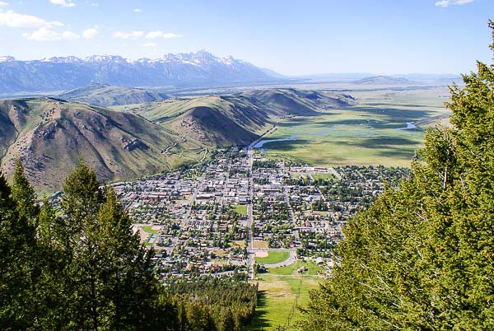

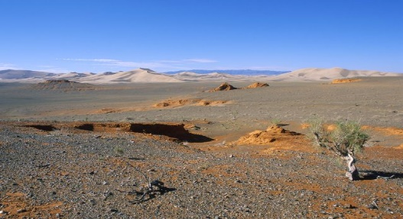

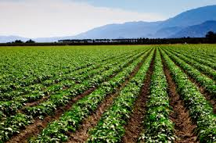

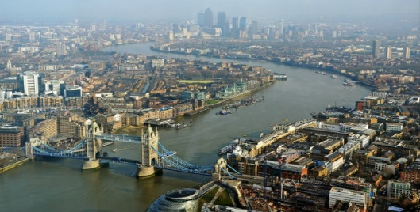

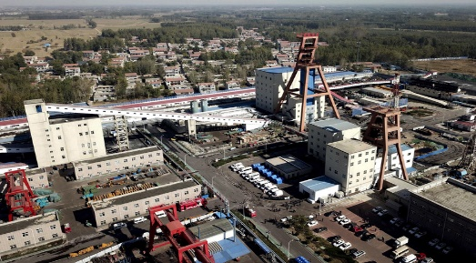

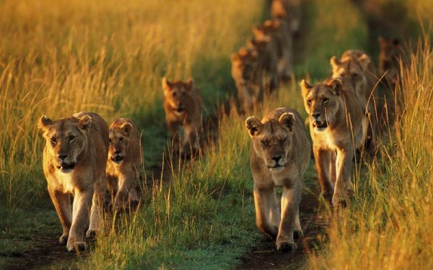

Part 2 – Human Factors
Identify the image from the first column, give it a suitable factor title and then explain how it influences population distribution.
Photo | Geographic Factor Title | Explanation of relevance
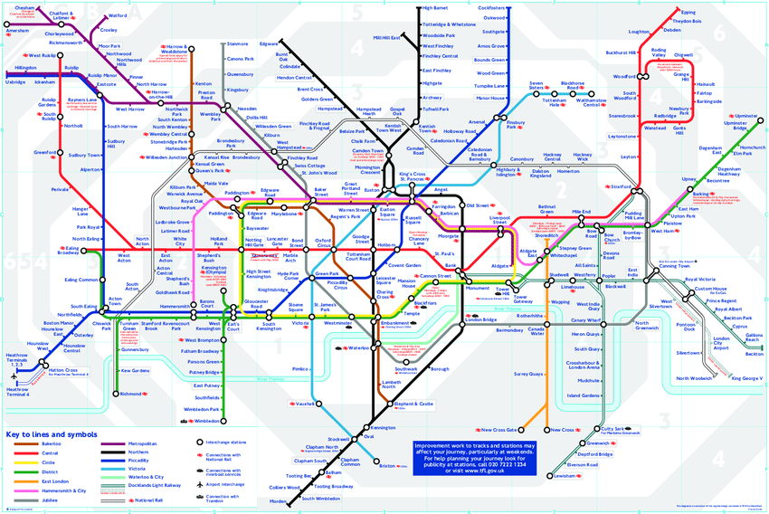

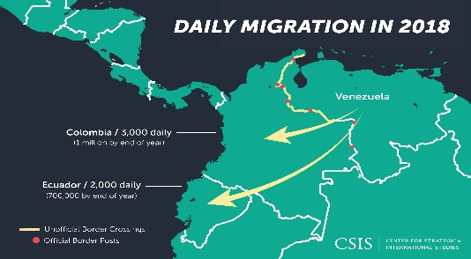

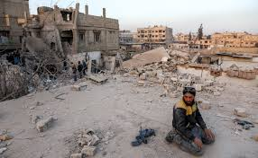

Physical factors rather than human factors are more important in determining population density of a place. To what extent do you agree with this statement?

