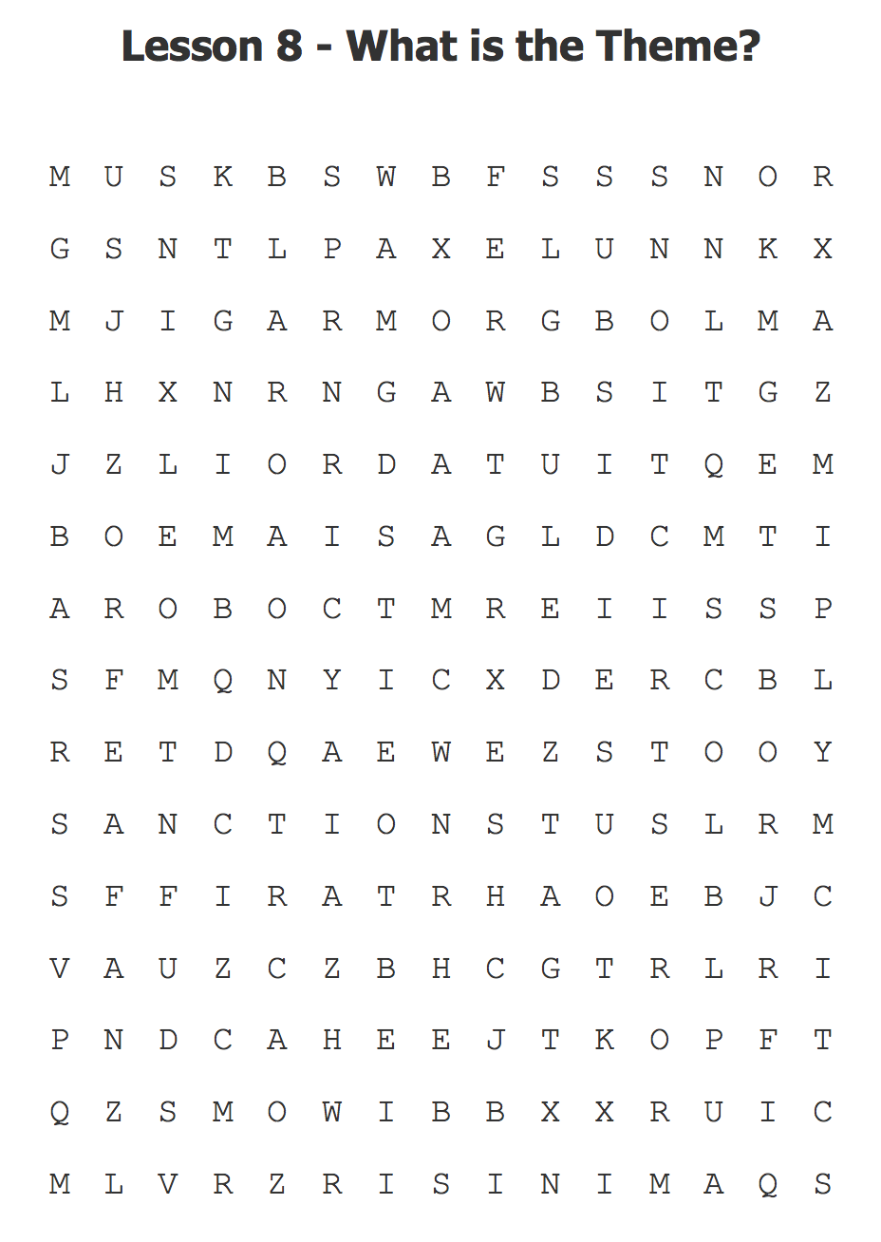

Lesson 7 What is the Theme?