**UNIT 1: FOUNDATIONS IN MANAGEMENT**

**Lesson 1: The Role of the Manager**

1. Challenges in working today

2. What are managers and what do they do?



*3 levels of management:*

3. Types of Manager:

4. The Management Process

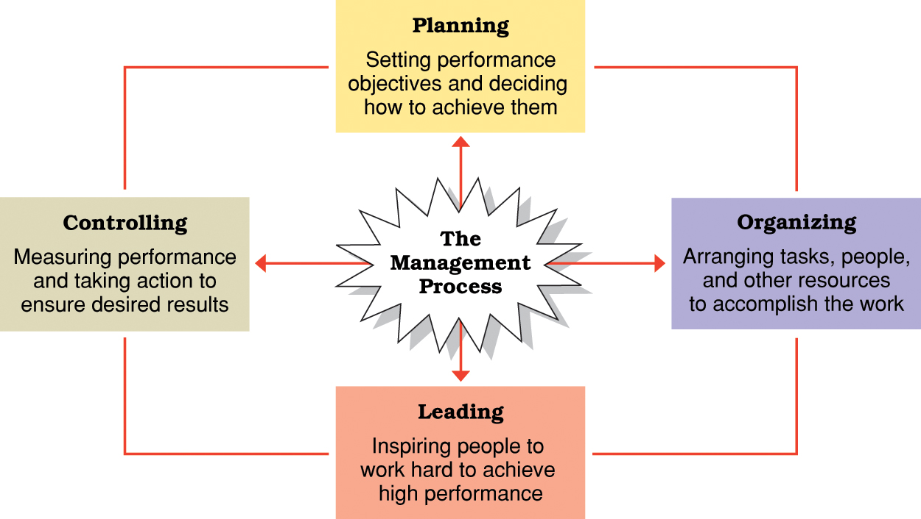

5. Daniel Katz’s Essential Managerial Skills

