**Lesson 2. Finding a new Perspective**

**Step 1:** Choose one of the issues below

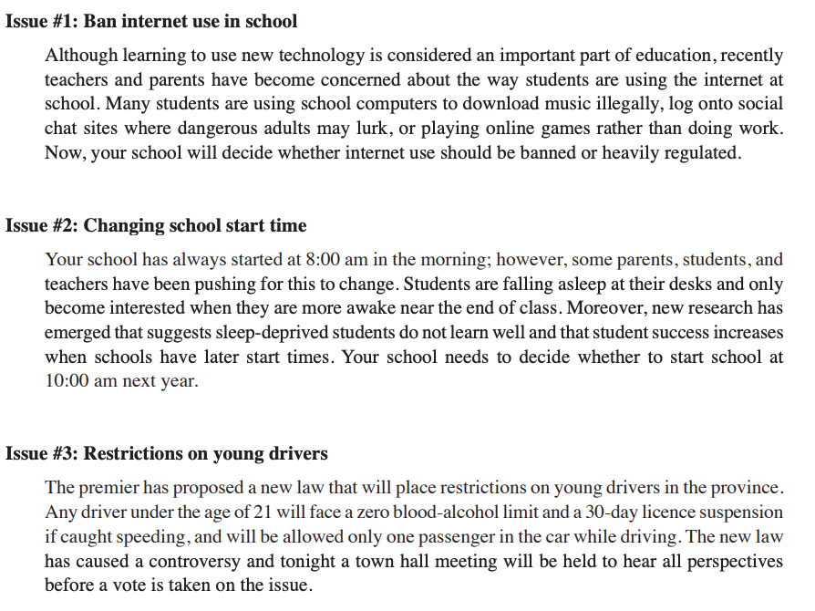

**Step 2:** Complete the template on the following page by following the next steps:

• Identify the perspective reflected in the source you already have.

• Brainstorm all the other stakeholders (people or groups who might be affected by or have an interest in the event or issue).

• Speculate how each stakeholders’ perspective might be different and why each perspective is important.

• Select those groups or individuals whose perspective is likely to be most useful in expanding your understanding of the issue or event.

• Brainstorm various places where you might find out about each perspective.

• Actively search for alternative perspectives.

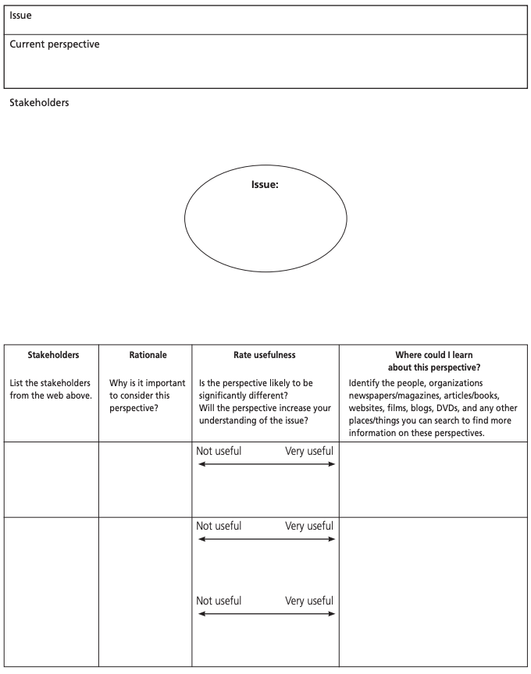

**Sample Answer**

