|  |
| --- |
| **Lesson 7. Ageing & Dependency Ratios** |

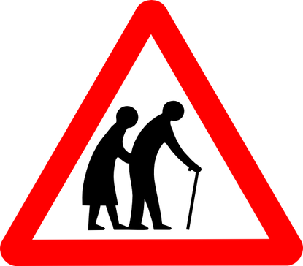

**Task 1.** Study the PDF report – Lesson 7. Demographic Dependency Ratios, and answer the following questions:

|  |
| --- |
| Q1. How is the ageing ratio calculated: |
|  |

|  |
| --- |
| Q2. Is the problem of ageing population just limited to developed countries and their societies? |
|  |

|  |
| --- |
| Q3. What does OECD stand for and what do they do? |
|  |

|  |
| --- |
| Q4. Turn to the table on page 2 and complete the following activities:  Study the Elderly dependency ratio projected figures for 2050 for OECD down to Latin America & the Caribbean and create a simple bar chart to show the ratio totals for each zone. Paste your Excel graph below. |
|  |

|  |
| --- |
| Q5. Comment on the graph above comparing different regions of the world and their future issues with an elderly population. Target 150 words |
|  |

|  |
| --- |
| Q6. Create another simple comparative bar chart but this time for the Total Dependency Ratio for the same regions for 2050 projected. Copy the graph into the space provided below. |
|  |

|  |
| --- |
| Q7. Comment on the graph above comparing different regions of the world and their future issues with an elderly population. Target 150 words |
|  |

|  |
| --- |
| Q8. A good and bad message? Who must shoulder the burden of an increasing dependent population? Why does the current financial crisis make this more difficult? |
|  |

|  |
| --- |
| **Case Study – The French Baby Boom!** |
| **Task 2.** Read the articles and watch the videos attached on your learning platform. |

|  |
| --- |
| 1. Create a 5 W’s mind map about the French Baby Boom. 2. Evaluate the extent to which you think France's pro-natalist policies have been a success. Make sure you explain your answer and give evidence from the articles to support your points. |

**Task 3.** Read the article linked on the learning platform about the weird and wonderful methods that different countries have employed to increase birth rates and combat ageing populations

|  |
| --- |
| Make in depth notes on two different examples. |
| Case study 1 |
| Case study 2 |