REVISION SHEET 1
UNIT 1: THE EARTH – A VIBRANT PLANET
Task 1: Define the following key terms: [K 17]
Key Term | Definition
Biosphere
Lithosphere
Atmosphere
Hydrosphere
Cryosphere
Crust
Mantle
Inner Core
Outer Core
Continental Drift
Pangaea
Rotation
Revolution
Eccentricity
Precession
Obliquity
Park Disaster Model

Task 2: Label the following diagram: [K 4]
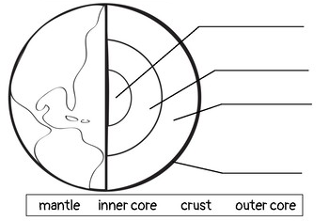
Task 3: Describe the layers of the Earth: [T 4]
Crust:
Mantle:
Inner Core:
Outer Core:
Task 4: Explain THREE pieces of evidence that can be used to support the theory of Continental Drift.
[T 6]
Task 5: Explain the Milankovitch Theories and how they can affect climate. [T 6]
1. Precession
2. Obliquity
3. Eccentricity
Task 6: Draw and annotate Park’s Disaster Model. [A 6]

UNIT 2: THE LITHOSPHERE
- What is an earthquake? Explain HOW an earthquake happens.
- How are body waves and surface waves different (earthquakes)?
- Describe the difference between the focus and the epicenter of an earthquake.
- Compare the different types of plate boundaries, and explain what can happen at each. (Convergent collision, convergent subductive, divergent, and transform)
- Anatomy of a volcano – diagram
- Explain how and why intraplate volcanism (hotspots) occur.
- Case Study: Yellowstone Super Volcano
- Richter Scale and Mercalli Scale – what do they show?

UNIT 3: THE ATMOSPHERE
- Label the different layers of the atmosphere and give characteristics of each.
- Explain the Hadley, Polar and Ferrel cells.
- Explain the Inter Tropical Convergence Zone and how it impacts climate.
- Construct and interpret a climate graph.
- Explain how a tropical storm forms.
- Explain some of the devastating effects of Hurricane Katrina OR Typhoon Haiyan.
- Explain why storms are becoming stronger and more frequent – climate change.
- GIS – what is it? How can it help countries prepare for tropical storms?

UNIT 4: THE HYDROPSHERE
- Ocean currents – The Great Ocean Conveyor Belt and Gyres
- The Great Pacific Garbage Patch
- El Niño and La Niña – causes and effects (teleconnections)
- Waves – key terms
- Types of wave – constructive and destructive
- Four types of erosion
- The formation of ONE coastal landform (the one you studied in class)
- Physical and human causes of flooding
- River Hydrographs – key terms, how to draw, how to interpret
- Pakistan Flood 2010 Case Study – location, causes and effects
- Hydro-politics
- Hydro-politics case studies

